ENERGY MANAGEMENT BY USING HIGH EFFICIENT ZIGBEE TECHNOLOGY IN SMART OFFICIES

Abstract:

Now-a-days demand for electrical is more. So we need to control the energy consumption. If the energy consumption is less, then generation will be less. So the energy resources may work efficiently. There are many controllers to control the energy consumption. For the better performance in the reduction of power consumption a wireless technology named zigbee is using. It is a hardware embedded protocol network. It consists of sensor and controlling network.

The main objective of this project is to reduce the power consumption and using the energy in the efficient manner by using the mesh network topology protocol.

Keywords:

Zigbee, lcd, 8051 Microcontroller.

Introduction:

The increasing number of wireless-based applications and technologies is changing the mentality and the rules of most Information Technologies systems. In the recent years, developments in the semiconductor industry have enabled the appearance of small, cheap and simple devices, known as sensor nodes. These nodes are capable to sense a number of physical magnitudes to transmit and receive information to and from other nodes, and to beneﬁt from the low power consumption of its components, resulting in controlled power autonomy.

One of the main challenges that the development of this kind of network presents is to decrease the power consumption as much as possible, extending the lifetime of the battery powered nodes long enough to be considered a good option for scenarios where battery replacement must be done as seldom as possible. Extending the battery life long enough can greatly improve the possible applications and boost the commercial success.

Zigbee Technology:

Zigbee originates from honeybee method of communicating new found food sources. Zigbee IEEE 802.15.4 stack is one of the most popular choices for wireless sensor network. Zigbee is used to create the wireless personal area network (WPAN). This network forming, routing and security protocols.

Zigbee device consists of three devices.

1. Zigbee Coordinator (ZC)
2. Zigbee Router (ZR)
3. Zigbee End Device (ZED)

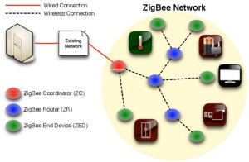

**Zigbee Coordinator (ZC):**

The coordinator storing the information while performing receiving and transmitting data operations.

**Zigbee Router (ZR):**

The routers act as intermediary. That allows data to pass to and fro.

**Zigbee End Devices (ZEB):**

End devices have limited functionality, such that the saving of battery power.

**Zigbee topologies:**

1. Star 2.Cluster tree 3.Mesh

In this project mesh network is mainly used.

Block diagram:

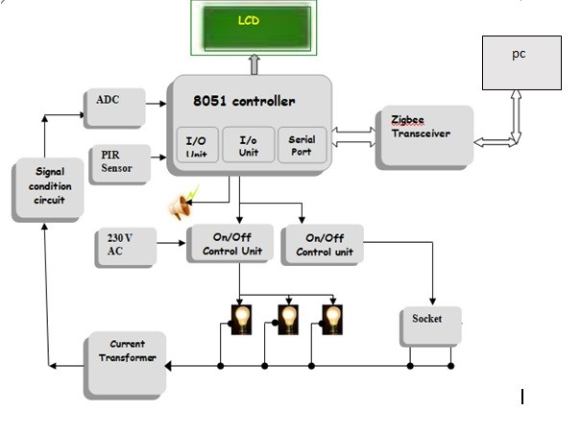

This project focuses on active power management in electric power system using emerging embedded technology.

Required Components:

1. 8051 microcontroller

2. Current Transformer

3. Analog to Digital Converter

4. Electrical load

5. Buzzer

6. Power supply

7. Electromagnetic Relay

8. PIR Sensor

9. LCD

Explanation of project:

The load is connected with on/off controls switches like relays. These relays are connected to the 8051 microcontroller. When the power supply is on load consumes power. So the amount of power consumed is measured by the current transformer. Current transformer measures the amount of current in the load.These current signals are given to the signal conditional circuit.Signal conditional circuit manipulates the incoming signals into required form which are useful for the further process. Here current signals are converted into voltage.ADC converts the analog signals into digital signals. These digital signals are given to the 8051 microcontroller. In this microcontroller a program is written to calculate the amount of consumed power .PIR sensor also connected to the microcontroller. It detects the motion and sends the digital signals to the microcontroller. Here microcontroller is connected to LCD. The data from the 8051 microcontroller goes to the zigbee coordinator. From the coordinator data goes to end device. Here zigbee acts as transreceiver.So the information is connected to computer. Zigbee is a high level protocol device.It secures the data and saves the life time of the battery when compare to wifi and bluetooth.

In order to power saving we propose two type of mode.

1. PIR MODE

2. NON PIR MODE

when the usage power is beyond the limited power automatically the alarm rings to alert the consumers in order to switch off the unused appliances within ten minutes.

Hardware:

8051 Microcontroller:

The Microcontroller used in this project has the specifications like

8 bit Microcontroller,64KB Flash memory,1KB RAM,32 Bi-directional, I/O lines,High Performance ,ON-Chip Peripherals,6 clock/12 clock operation,20MHZ Oscillator,External Memory 64KB,In System Programming Facility.

PIR sensor:

PIR stands for Passive Infrared. It measures infrared light from objects in its field of view. PIR sensors allow you to sense motion, almost always used to detect whether a human has moved in or out of the sensors range.

LCD:

A liquid crystal display (LCD) A is an electronically modulated optical device.It has two states combinations, the liquid and solid.

Software Requirements:

1. Keil or RIDE

Programming Language:

Embedded C Language

Comparision of wireless technologies:

|  |  |  |  |
| --- | --- | --- | --- |
| Wireless Parameter | Bluetooth | Wifi | Zigbee |
| Frequency band | 2.4 GHz | 2.4 GHz | 2.4 GHz |
| Physical/MAC layers | IEEE 802.15.1 | IEEE 802.11.b | IEEE 802.15.4 |
| Range | 9 m | 75 to 90 m | Indoors: up to 30 m Outdoors (line of sight): up to 100 m |
| Current consumption | 60 mA (Tx mode)  400 | 400 mA (Tx mode) 20 mA (Standby mode) | 25-35 mA (Tx mode) 3 µA (Standby mode) |
| Raw data rate | 1 Mbps | 11 Mbps | 250 Kbps |
| Protocol stack size | 250 KB | 1 MB | 32 KB 4 KB (for limited function end devices |
| Typical network join time | >3 sec | variable, 1 sec typically | 30 ms typically |
| Interference avoidance method | FHSS (frequency hopping spread spectrum) | DSSS (direct-sequence spread spectrum | DSSS (direct-sequence spread spectrum |
| Minimum quiet bandwidth required | 15 MHz (dynamic) | 22 MHz (static) | 3 MHz (static) |

Conclusion:

When compared to other wireless technologies like wifi and bluetooth, zigbee is more efficient, completeness, accuracy, reliability, suitability or availability and more lifetime for battery. Mainly it is useful for the low data rate devices. So when distance is more zigbee can work efficiently and can control the load in the offices with the smart device. Therefore, low cost solution for sensing and controlling.

References:

1.Yuanguai LIN, Haixia XIE, WeiYANG, Xingwu ZHENG,” Design of Zigbee Gateway in Intelligent Monitoring System for Agriculture”, 2011 International Conference on Mechatronic Science, Electric Engineering and Computer August 19-22, 2011, Jilin, China.

2. IEEE 802.15 Work Group. http://www.ieee802.org/15/. 3

3. ZigBee Speciﬁcation 2006. ZigBee Alliance, Dec. 2006. 11, 87, 92.

4. Li Da Xu, Wu He, Shancang Li. “Internet of Things in Industries: A Survey. IEEE Transactions on Industrial Informatics”. DOI 10.1109/TII.2014.2300753.

5. Demirkol, I., Ersoy, C., and Alagoz, F. Mac protocols for wireless sensor networks: a survey. IEEE Communications Magazine (2006). 40

Hands-on ZigBee: implementing 802.15.4 with microcontrollers"

Fredeady

Fredeady

Hands-on ZigBee: implementing 802.15.4 with microcontrollers"

Fredeady